**iPad issues**

1. Change User link is not visible on the page
2. Grant Number does not fit
3. Table is going out of the allocated space

**Specialist Hitlist**

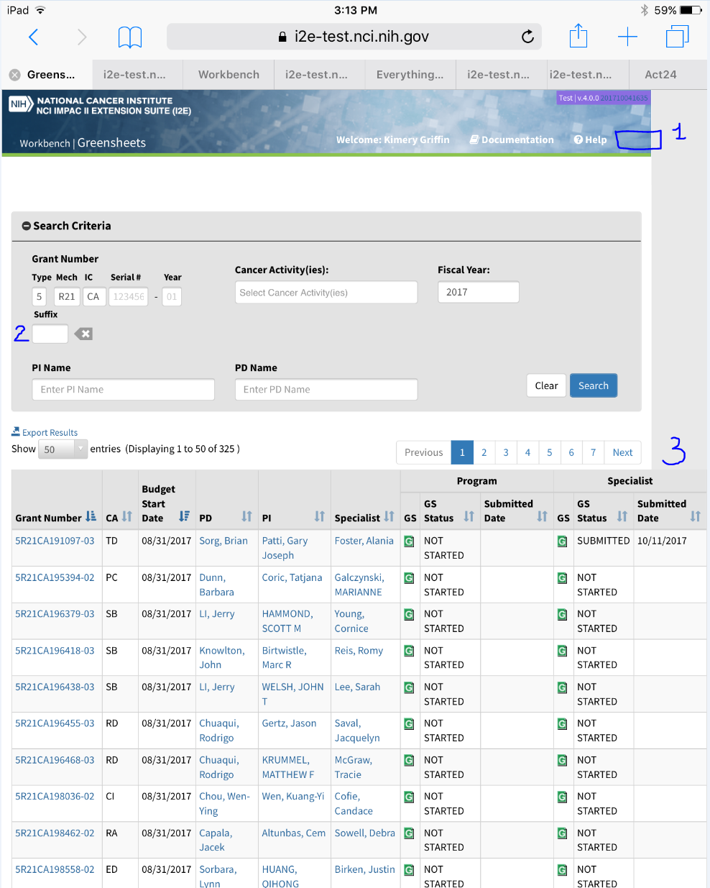

**Program Hitlist**

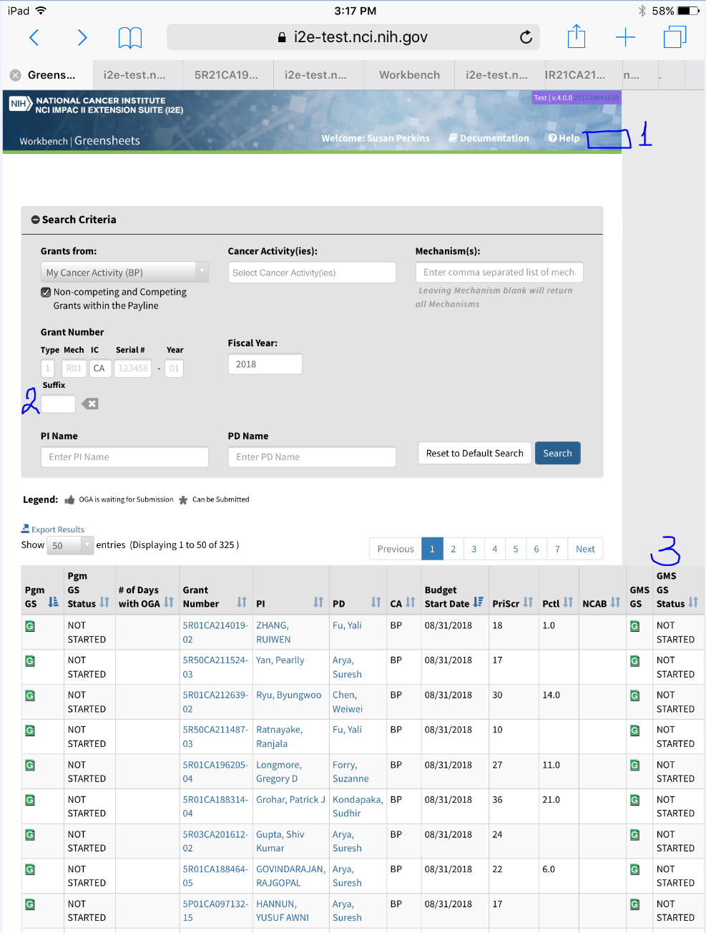

1. Error and Success message covers the page title

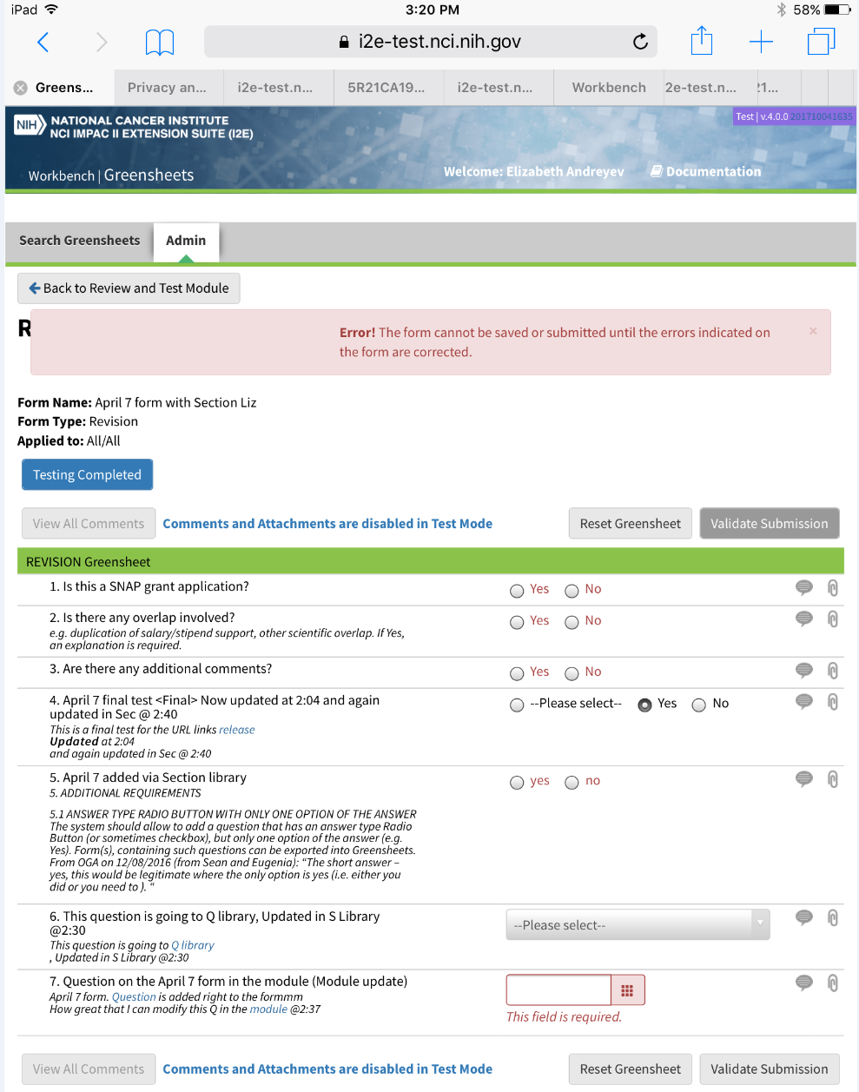

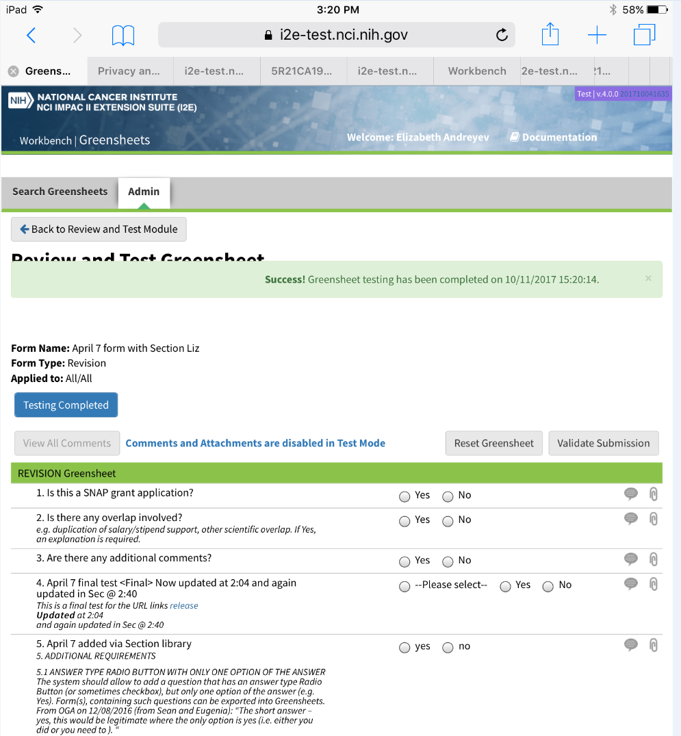

1. No Help or Change User links are displayed on the Admin tab

